**Adding Database to our Project**

### **Objective**

We want to add time when we turned Lights on to our Database Let us learn how to do that for this, we would be using SQlite3 and make sure to download DB browser on Raspberry pi to open your database file.

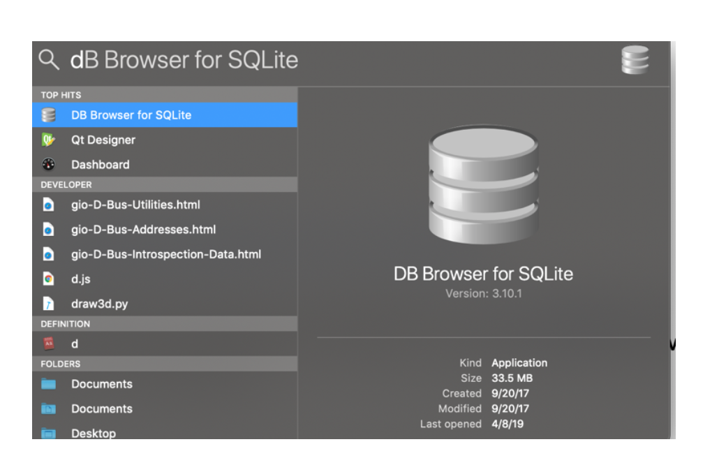

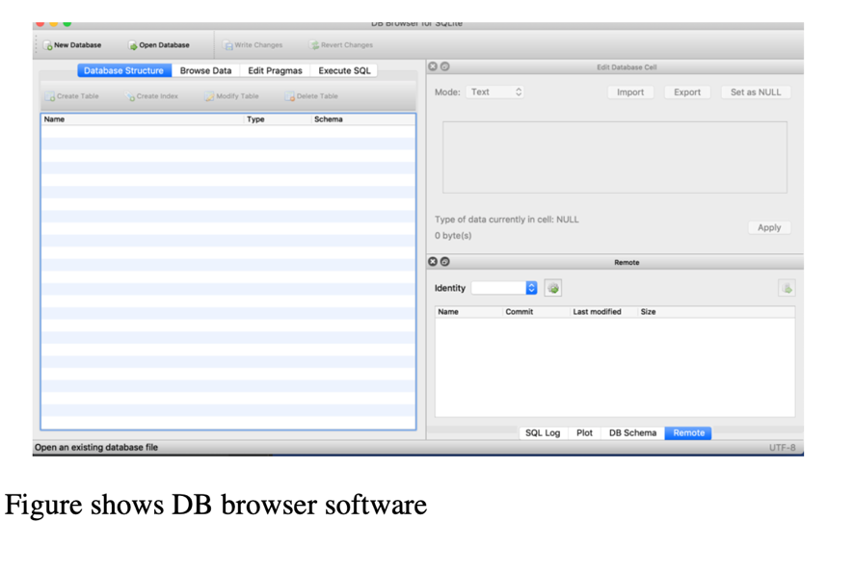

## CIRCUIT DIAGRAM:

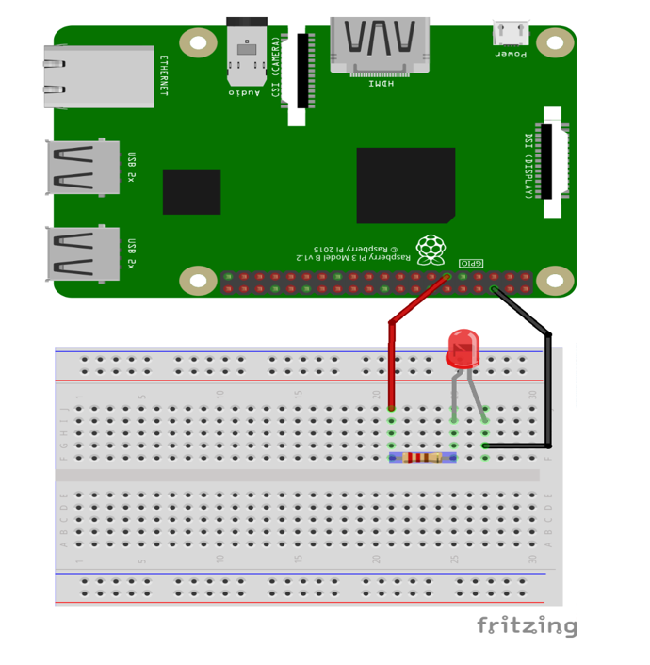

Code:

*# import the important library*

**import** **tkinter** **as** **tk**

**import** **RPi.GPIO** **as** **GPIO**

**import** **time**

**import** **datetime**

**import** **sqlite3**

GPIO.setmode(GPIO.BOARD) *# to use Raspberry Pi board pin numbers*

GPIO.setup(11, GPIO.OUT) *# set up GPIO output channel*

mainwindow=tk.Tk()

mainwindow.title('Test ')

mainwindow.geometry('640x340')

my_label=tk.Label(mainwindow,text="My First UI",

font=("Arial",22), bg= "Green",fg="white")

my_label.grid(row=0,column=0,sticky='NSEW',padx=10,pady=10)

button_on=tk.Button(mainwindow,text="On",bg="black",fg="white",

command=**lambda** :my_on())

button_on.grid(row=1,column=0,sticky='NSEW',padx=10,pady=10)

button_off=tk.Button(mainwindow,text="OFF",bg="black",fg="white",

command=**lambda**:my_off())

button_off.grid(row=1,column=1,columnspa=1,sticky='NSEW',padx=10,pady=10)

**def** my_on():

t=datetime.datetime.now()

my_t = "**{}**-**{}**-**{}**".format(t.hour,t.minute,t.second)

database_on(my_t)

print('Led Turn On !!!!! ')

GPIO.output(11, GPIO.LOW) *# set RPi board pin 11 low. Turn off LED.*

time.sleep(1)

print('Yes you did it !')

**def** my_off():

t=datetime.datetime.now()

my_off = "**{}**-**{}**-**{}**".format(t.hour,t.minute,t.second)

database_off(my_off)

print('Led Turned Off !!!!!! ')

GPIO.output(11, GPIO.HIGH) *# set RPi board pin 11 high. Turn on LED.*

time.sleep(2)

print('Great Work ! ')

**def** database_on(on_time):

conn = sqlite3.connect('led.db')

cursor = conn.cursor()

cursor.execute(""" CREATE TABLE IF NOT EXISTS

ledon

(id INTEGER PRIMARY KEY AUTOINCREMENT NOT NULL,

on_time TEXT)""")

cursor.execute("""

INSERT INTO ledon (on_time)

VALUES (?)""", (on_time))

conn.commit()

cursor.close()

conn.close()

**def** database_off(of_time):

conn = sqlite3.connect('led.db')

cursor = conn.cursor()

cursor.execute(""" CREATE TABLE IF NOT EXISTS

ledoff

(id INTEGER PRIMARY KEY AUTOINCREMENT NOT NULL,

off_time TEXT)""")

cursor.execute("""

INSERT INTO ledoff (off_time)

VALUES (?)""", (of_time))

conn.commit()

cursor.close()

conn.close()

mainwindow.mainloop()